Configuration Description, Deployment,
and Lifecycle Management

A Service API for Deployment

Draft 2004-10-11
Status of this Memo
This document provides information to the community regarding the specification of the Configuration Description, Deployment, and Lifecycle Management (CDDLM) Language. Distribution of this document is unlimited. This is a DRAFT document and continues to be revised.

Abstract
Successful realization of the Grid vision of a broadly applicable and adopted framework for distributed system integration, virtualization, and management requires the support for configuring Grid services, their deployment, and managing their lifecycle. A major part of this framework is a language in which to describe the components and systems that are required. This document, produced by the CDDLM working group within the Global Grid Forum (GGF), provides a definition of the service API whereby a Grid Resource is configured, instantiated, and destroyed.


GLOBAL GRID FORUM
office@ggf.org
www.ggf.org

Full Copyright Notice
Copyright © Global Grid Forum (2004). All Rights Reserved.
This document and translations of it may be copied and furnished to others, and derivative works that comment on or otherwise explain it or assist in its implementation may be prepared, copied, published and distributed, in whole or in part, without restriction of any kind, provided that the above copyright notice and this paragraph are included on all such copies and derivative works. However, this document itself may not be modified in any way, such as by removing the copyright notice or references to the GGF or other organizations, except as needed for the purpose of developing Grid Recommendations in which case the procedures for copyrights defined in the GGF Document process must be followed, or as required to translate it into languages other than English.
The limited permissions granted above are perpetual and will not be revoked by the GGF or its successors or assigns.
This document and the information contained herein is provided on an "AS IS" basis and THE GLOBAL GRID FORUM DISCLAIMS ALL WARRANTIES, EXPRESS OR IMPLIED, INCLUDING BUT NOT LIMITED TO ANY WARRANTY THAT THE USE OF THE INFORMATION HEREIN WILL NOT INFRINGE ANY RIGHTS OR ANY IMPLIED WARRANTIES OF MERCHANTABILITY OR FITNESS FOR A PARTICULAR PURPOSE.
Intellectual Property Statement
The GGF takes no position regarding the validity or scope of any intellectual property or other rights that might be claimed to pertain to the implementation or use of the technology described in this document or the extent to which any license under such rights might or might not be available; neither does it represent that it has made any effort to identify any such rights. Copies of claims of rights made available for publication and any assurances of licenses to be made available, or the result of an attempt made to obtain a general license or permission for the use of such proprietary rights by implementers or users of this specification can be obtained from the GGF Secretariat.
The GGF invites any interested party to bring to its attention any copyrights, patents or patent applications, or other proprietary rights which may cover technology that may be required to practice this recommendation. Please address the information to the GGF Executive Director (see contact information at GGF website).

Table of Contents
Configuration Description, Deployment, and Lifecycle Management 1
A Service API for Deployment 1
Draft 2004-10-11 1
1 Table of Contents 3
2 Introduction 4
3 CDDLM-WG and the Purpose of this Document 4
4 End-user Deployment Portal Needs 4
4.1 Out of scope: 5
4.1.1 File upload 5
4.1.2 Discovery and binding 5
5 Core Concepts 5
5.1 Conceptual Model 5
5.2 A Lifecycle to match CDDLM components 5
5.3 Web Service interface 7
5.4 Language Agnostic, 7
5.5 Extensible through options 7
5.6 Deploy-time properties in the language and service API 7
5.7 Service Interrogation operations 8
5.8 Application Interrogation 8
5.9 Support lifecycle event notifications 8
5.10 Permit multiple notification protocols 8
5.11 Fault Policy 8
5.12 Naming and identification 9
6 Deployment Service API 9
6.1 Overview 9
6.2 Application identifiers 9
6.3 Namespaces 10
6.4 Extra operations 10
6.5 create 10
6.6 undeploy 10
6.7 setCallback 10
6.8 applicationStatus 11
6.9 ServerStatus 11
6.10 listApplications 12
6.11 lookupApplication 12
7.1 Language Support 12
7.2 Options 12
8 Proposal 13
8.1.1 Message <deploy> 13
8.1.2 Message <terminateApplication> 14
8.1.3 Message <getApplicationStatus> 14
8.1.4 Message <getServerInfo> 14
9 Security 14
10 Editor Information 15
References 15
Appendix A: Faults 16

Introduction
The CDDLM framework needs to provide a deployment API for programs submitting jobs into the system for deployment, terminating existing jobs, and probing the state of the system.
This document defines the SOAP-based deployment API.
The key words "MUST", "MUST NOT", "REQUIRED", "SHALL", "SHALL NOT", "SHOULD", "SHOULD NOT", "RECOMMENDED", "MAY", and "OPTIONAL" in this document are to be interpreted as described in RFC 2119 [].

CDDLM-WG and the Purpose of this Document

The CDDLM WG addresses how to: describe configuration of services; deploy them on the Grid; and manage their deployment lifecycle (instantiate, initiate, start, stop, restart, etc.). The intent of the WG is to gather researchers, developers, practitioners, and theoreticians in the areas of services and application configuration, deployment, and deployment life-cycle management and to explore the community need for a broader effort in this area. The target of the CDDLM WG is to come up with the specifications for CDDML a) language, b) component model, and c) basic services. This document represents the component model specification. This specification is derived from the SmartFrog framework developed at HP Labs, and other industry specifications.
This document describes the component model of the framework. It does not describe any required component libraries. The design of the system is loose to allow the binding of attributes to deployment objects to be handled by an individual implementation of the system. This document serves to outline the requirements for a software object to be deployable by the CDDLM framework.

End-user Deployment Portal Needs
We assume that the end user is deploying through a console program, a portal UI or some automated process. This program will be something written by a third party to facilitate deployment onto a grid fabric or other network infrastructure which is running instances of the CDDLM basic services.
There are three different use cases being examined here
- The deployment target is an OGSA-compliant Grid Fabric. Resource allocation and Job submission (using JSDL) is part of the deployment process. In this use case, the deployment API must integrate with the negotiation, and deploy a CDDLM-language described system over the machines allocated by the resource manager.
- The deployment target is a pre-allocated cluster set of machines. The resource allocation process is bypassed -it can be presumed to have happened out of band.
- One instance of a CDDLM runtime is delegating part of a deployment to another host. There is no guarantee that the two runtimes are the same implementation of CDDLM, or, if they are, that they are the same version.

Out of scope:
The following activities are not covered by the service API.

File upload
Uploading files to the systems is not addressed. We are assuming that other mechanisms -specifically a JSDL-based front end to the system- will address that problem by retrieving the files and offering them somewhere that deployment hosts can retrieve by means of a URL.
We do need a way of knowing the mapping from the identification of files in the job submission. This can be either by having the front end generate a new deployment descriptor which includes this information, or by providing a name/value mapping list alongside the descriptor.

Discovery and binding
We assume that registration of, discovery of and binding to service instances is handled by external discovery and binding mechanisms.

Core Concepts

Conceptual Model
The core model for deployment is that the caller first issues a request to create an application on the server. This request includes a deployment descriptor and other information that describes and the application. The response from a successful creation will be a URI that identifies the application. This application URI is used in following requests, to indicate to which application the request refers.
Once an application has been created, it can be started, and later, terminated. An application can also fail, which means that a component in the application has failed, and that information has propagated to the parent component of the entire application. A failed application can only be terminated. The complete lifecycle is defined in section 5.2.
As an application moves through its stages of the lifecycle, it can send lifecycle event notification messages to a registered listener. It can also be polled with a status request. A status request is a blocking call to query the state of the listener.

A Lifecycle to match CDDLM components
CDDLM components have a well defined lifecycle, one that is covered in the component model specification []. The lifecycle of a deployment matches the lifecycle of the components within. This is essential to permit delegation, in which a component can be built to manage the entire deployment of an application to a remote system using the deployment API.
The lifecycle is as follows
instantiated | the application has just bee instantiated
initialized | The application has been initialized
running | The application is running
failed | The application has failed
terminated | The application has terminated

The normative definition of this lifecycle is the component model. Instantiation and initialization cover the creation and configuration of a component, and when it is moved into running then it is actually functioning, The state failed is entered automatically when a failure is detected; termination is the only exit condition; terminated is the end state of a component and can be entered through a termination request.
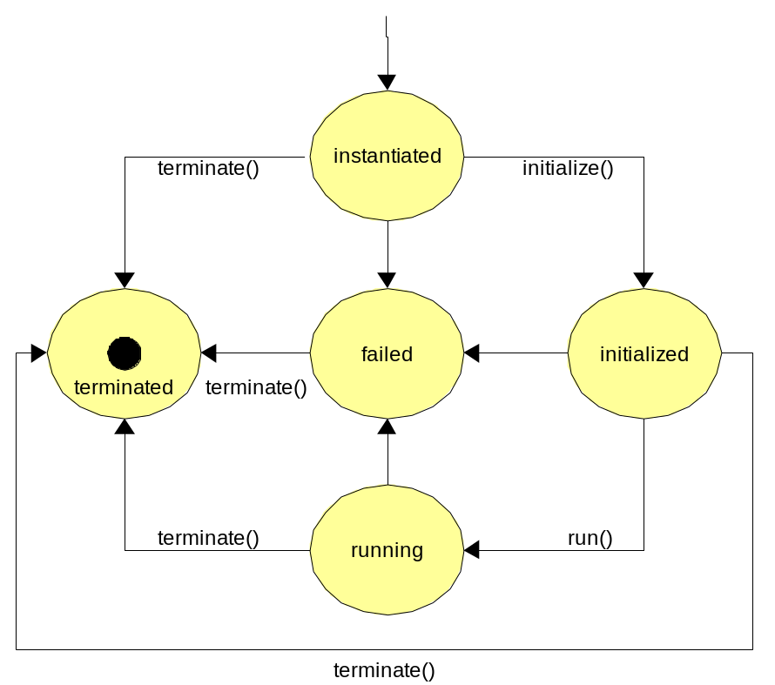
The lifecycle is exposed through the operations of the service. The create operation is will create and instantiate an application. The run operation will move the application to the running state, and terminate will move it to the terminated state.

Web Service interface
The service API is based up on the WS-I set of Web Service Specifications. This is in line with the UK NeSC Policy [], and means that the infrastructure does not mandate the use of higher level Web Service technologies. This creates one major problem, that of notifications, which is addressed later, in section [5.10].

Language Agnostic,
The deployment API is agnostic as to which particular language is being used, or which version of that language. When a remote deployment is created, the language and version of the descriptor must be supplied. The sole requirement is that it can either be nested inside a SOAP request, or that a URL to the descriptor is remotely accessible to the destination.

Extensible
It is inevitable that different implementations of the framework will, over time, have different features which can be used to control and configure a deployment. While the deployment API does not address the need to offer new operations by the service endpoints, it does allow the operation

Deploy-time properties in the language and service API
Consider a deployment descriptor that declares the host that it wants different components to deploy to. When the descriptor is written, the actual hosts are unknown, so placeholders have to be used. It is only during deployment that the mapping becomes apparent. Either the descriptor is rewritten with the fixed values, or we provide a way for subsidiary information to be passed alongside the descriptor.
The SmartFrog language supports this with the PROPERTY and IPROPERTY keywords, which bind keys in the Java virtual machine's java.System.Properties global HashTable to string and integer values []. For example, a deployment descriptor could be bound to three properties:

database extends Database {
sfHostname PROPERTY hosts.database;
password PROPERTY database.password;
localhost LAZY PROPERTY local.hostname
}
At deployment time, the value of the property string is extracted and assigned to the attribute, or a resolution fault is raised. The LAZY keyword indicates that the evaluation is not to take place in the context of the process interpreting the deployment descriptor, but instead the system actually hosting it. As Java System properties are extractable, this can make a significant difference. Although the XML language does not explicitly contain such a feature, a standardized component could be designed to extract the values from the name/value list.
To enable this functionality within the Service interface a set of name/value pairs is one of the options that be specified when creating a deployed application.

Service Interrogation operations
The service API defines an operation to get the state of the server, including lists of supported languages, notifications, and creation-time options. This can be used to verify that an implementation meets the caller's basic needs, without having to actually deploy an application.
A separate operation will return a list of deployed applications.

Application Interrogation
An application can be probed as to its health, as per the component model. This will return its current state, and any custom status information the application chooses to return. If the application has failed, or terminated after a failure, the status information will include the fault information.
This information is adequate to permit polling as a somewhat inefficient means of checking up on the health of a deployed application, but it has the advantage of allowing service consumers behind firewalls to inquire of the system.

Supports lifecycle event notifications
A monitor can register an interest in an application, to receive lifecycle event notifications. These are messages which are sent on every state transition, and include the current applications status information and a timestamp.

Supports multiple notification protocols
This was a design decision to reflect the current state of instability of standards and specifications in the Web Service notification area. Ultimately, we expect the current WS-Notification and WS-Eventing specifications will converge to a single standard, but to date both standards are still stabilising. There is also the challenge of routing mesages through firewalls; the relayed XMPP protocol may retain a role in solving this problem.
Until there is a single notification mechanism, the deployment API leaves the exact selection of notification mechanism to implementations. The server information request can obtain the list of supported notification mechanisms; a caller can then submit a request to be notified using their chosen protocol.
This is a somewhat imperfect solution -a single notification mechanism across all implementations aids deployment. All implementations should adopt WS-Notification as soon as it is deemed ready.

Deployment Service API Overview

Operations
There is a single endpoint for the deployment service. It offers seven operations.
Operation | meaning
create | Deploy an application described by the nested descriptor
run | move a created application to the running state
terminate | Move an application to the terminated state
setNotification | Set or clear the lifecycle event notification for an application
applicationStatus | Check the current status of an application
listApplications | List all running applications
serverStatus | Get information about the server

Application identifiers
Deployed applications are identified by URIs.
- Every application is given a URI reference by the runtime, which is returned in the response to the create request.
- This URI may be opaque, or it may be a valid URL in a well-known URL schema.
- These URIs are only guaranteed to be unique on a single runtime, not across machines.
- URIs should be unique across restarts of the runtime. That is, a single host should never deploy two applications to the same URI.
- It is not possible to request the URI of application in a deployment request
- To locate applications or components in an application by well known names, applications should use discovery and binding mechanisms such as UDDI, or multicast DNS.

Namespaces
The namespaces for the different parts of the service API are normatively defined in the file constants.xml, which is part of the specification. For reference, they are:

http://gridforum.org/cddlm/serviceAPI/api/2004/10/11/ | Namespace of deployment API WSDL
http://gridforum.org/cddlm/serviceAPI/types/2004/10/11/ | Deployment API types
http://gridforge.org/cddlm/serviceAPI/faults/2004/10/11/ | Fault namespace

Extra operations
A service implementation may offer extra operations at the same endpoint as the deployment API. This is beyond the scope of this document, except to note that it is permissible. Such extensions must not add new declarations to the existing WSDL or XSD namespaces.

Fault Policy
This version of the deployment API uses conventional SOAP faults for fault information. A normative XML file accompanies the XSD and WSDL descriptions of the service, to provide URIs, names and descriptions of every standard fault in the service API.
The faults are listed in Appendix A; the normative declaration of their names and meanings is in an XML file that accompanies the WSDL.
The next draft of the specification will move to WS-BaseFaults, with a well defined fault that can contain the core fault model of the service API, and also nest SOAPFault or WS-BaseFault faults inside.

Service Operations

create: create a new application
This is the most complex request.
jsdl | Optional JSDL job description []
descriptor | A job descriptor or a URL to one
notification | Optional notification information
options | Optional configuration parameters

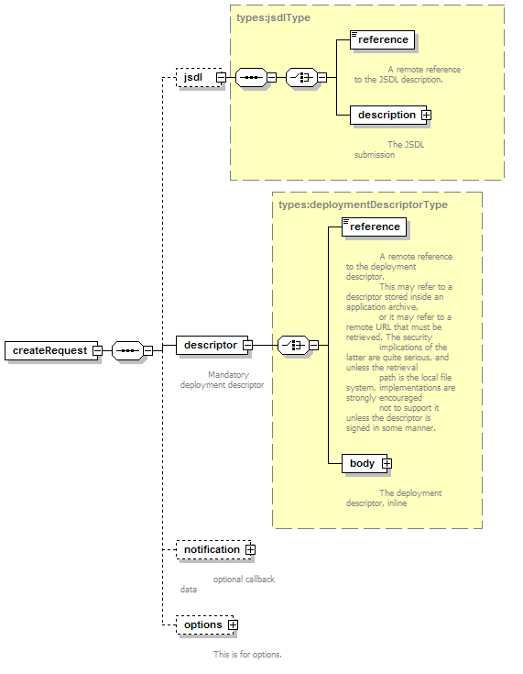

Element <jsdl>
The optional <jsdl> element contains the job description that was used when submitting the job to the front-end portal. The interpretation of this data by the service implementation is undefined.

Element <descriptor>
This element contains either a URL to a deployment descriptor, or the deployment descriptor itself.

Element <notification>
The optional notification element identifies what is to be notified about lifecycle events, and how.

Element <options>
This (optional) element contains a list of zero or more creation options. These are extra parameters to the deployment request.
The option list is a very powerful aspect of the API, but potentially dangerous. Any protocol standard which has optional aspects is harder to write clients against than one which does not, as there is likely to be less consistency between different implementations.
- All options must be that: optional. A service implementation must be able to create an application when the entire options portion of the request is empty.
- Every option configures a creation aspect of the remote system.
- Every option is named by a URI
- All URIs which begin http://gridforum.org/cddlm/ are reserved for the CDDLM standard options.
- Options can contain string, integer, Boolean or arbitrary XML values.
- All options that a service implementation supports must be enumerated in serverStatus requests.
- A b ce

The following rules must be adhered to when processing options
a nre

terminate
This operation terminates a named application. To be idempotent, this call does not raise a fault when an application is already terminated, or when the application is undefined. That is because there may be no record of the now-terminated application.
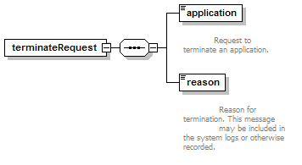

setCallback
This operation sets a lifecycle event callback for an application, or clears an existing application. Callbacks will be covered in more detail below.

applicationStatus
This operation probes the health of an application. The response -for a healthy application- is a simple message containing status information:-
<applicationStatusResponse >
<reference>http://localhost/cddlm/1095458549045/job1</reference>
<name>job1</name>
<state>running</state>
<callback>
<type>cddlm-prototype</type>
<address>
<uri>http://localhost:5051/client/callbacks</uri>
</address>
<identifier>1564</identifier>
</callback>
<stateInfo xsi:nil="true"/>
</applicationStatusResponse>

The operation probes the health of the root component of the deployment hierarchy, which return build up a model of the health of subsidiary components. The draft component model [component-model] specification covers this. The call blocks until the health check is complete.

ServerStatus
This operation returns the status of the server. The status is composed of a static section and a dynamic section. The static section includes server build information,

<serverStatusResponse xmlns="http://gridforum.org/cddlm/serviceAPI/types/2004/07/30">
<static>
<server>
<name>SmartFrog implementation</name>
<build>$Id: Constants.java,v 1.12 2004/09/15 12:59:13 steve_l Exp $</build>
<home>http://smartfrog.org/</home>
<location>unknown</location>
<timezoneUTCOffset>0</timezoneUTCOffset>
</server>
<languages>
<language>
<name>SmartFrog</name>
<version>1.0</version>
<namespace>http://gridforge.org/cddlm/smartfrog/2004/07/30</namespace>
</language>
<language>
<name>XML-CDL</name>
<version>0.1</version>
<namespace>http://gridforge.org/cddlm/xml/2004/07/30/</namespace>
</language>
</languages>
<callbacks>
<item>cddlm-prototype</item>
</callbacks>
<options>
<item>http://gridforum.org/cddlm/serviceAPI/options/name/2004/07/30</item>
<item>http://gridforum.org/cddlm/serviceAPI/options/propertyMap/2004/07/30
</item>
<item>http://gridforum.org/cddlm/serviceAPI/options/validateOnly/2004/07/30
</item>
</options>
</static>
<dynamic/>
</serverStatusResponse>

In this example, the server lists support for two languages, one prototype option and three deployment options; there is no dynamic status

listApplications
This operation returns a list of URIs of deployed application.

lookupApplication
This operation maps from a predefined application name to the current URI of an application deployed under that name. This is a vestigial operation that is likely to be removed in future.
Design Issues

Language Support
The protocol is independent of any particular configuration language; the sole requirement is that it must be embeddable inside the xsd:any section of the deployment descriptor, and that the namespace qualified name of the language must be unique enough to distinguish the language.
For the XML-CDL language, these attributes are implicit. To deploy SmartFrog content, we defined a minimal XML encoding, in which the entire document is encoded as text inside a suitably qualified element.
One interesting exercise would be to implement Apache Ant support [ant]. This may pose a challenge, as the core language is namespace-free XML; namespace support is a recent edition primarily to address task declaration clashes. As with SmartFrog, we may need to provide a wrapper element that declares an appropriate default namespace.
The alternate strategy for multi-language support would be to require explicit declaration of the language, and potentially the version of that language. This was not adopted as we felt that the XML namespace should provide all such information implicitly. It would be relatively easy to migrate to an explicit language declaration model. It may also improve readability for people viewing the wire format of the messages.

Options
The option mechanism offered in the deploy request provides a powerful, structured means of customising the deployment, either with specific options offered by a single implementation of the service API, or through widely-recognised options formally defined in group specifications.
As stated above, having optional aspects to a protocol with multiple implementations is potentially dangerous. If a program deploys expecting a particular option being available, and that option turns out to be absent, then things will not work as expected. The mustUnderstand attribute of each option lets the caller mandate which options must be understood, and the ability to enumerate available options in a serverStatus call provides the ability to enumerate the set of supported options without even attempting to deploy an application. These features , and the requirement that an option-free deployment must be supported reduces the risk of the option feature.
The next way to reduce risk is to standardise the names and semantics of common options. The ones we propose are
- validateOnly: a flag to indicate that the deployment descriptor should be validated to the best of the ability of the runtime, without being actually deployed.
- name: this is covered below; it specifies an explicit name for the application within the runtime, which can be entirely unrelated to the URI used in the service API.
- properties: a set of name-value pairs to define properties for examination by the deployment descriptor. These properties can be used for deployment-time customisation of a descriptor, without rewriting the descriptor itself. For example, properties could define the final locations of uploaded code files, mapped into the file system of the target machine.
- environment: A set of name-value pairs defining the environment variables of the deployed program. This is subtly different from the properties option, as the environment is part of the operating system or shell, and so effects the system more dramatically. The JSDL specification includes an environment block; this would be a mapping of the same block into the options section of the deployment request.

Proposal
- The service API is a WS-ResourceFramework compatible endpoint.
- All query-type requests will be described as WS-Resource attributes in the WSDL.
- Suitable "setter" requests will be similarly described.
    - Message <deploy>
The core request is <deploy>, which will take

Out
ApplicationReference: wsa:endpointReference
xsd:any minOccurs=0 : for future use

    - Message <terminateApplication>
In:
Application: identifier (wsa:endpointReference)
String: cause
boolean : synchronous flag
xsd:any minOccurs=0 : for future use
Out:
boolean: Success/failure response.
xsd:any minOccurs=0 : for future use
If the caller requested a synchronous termination, the call would not return until the termination process had succeeded or failed.
If the caller requested asynchronous termination, the call would return true if the message was accepted for processing.
    - Message <getApplicationStatus>
Probe the server for status about an application. This will be forwarded to the component representing the application, as a status request.
    - Message <getServerInfo>
Returns information about the server, as proposed in section Error: Reference source not found:
In
void
Out
<serverInfo>
The response contains agreed on content and an optional xsd:any element with any other information deemed of interest.

Security
It is imperative that the deployment requests are only made by suitably authorized individuals, or their suitably authorized agents.
For deployment to a Grid Fabric, that means that the standardized security model of the Grid infrastructure must be used to authenticate callers. Only callers with the relevant rights may deploy applications.
When delegating deployments across nodes, the node issuing the deployments needs to have the rights to do so, and the deployment itself still needs to be authenticated as a legitimate request of the sender. This is a hard problem.

Editor Information
Steve Loughran, HP Laboratories

References

Appendix A: Faults
(this appendix is generated by an XSL transformation of the file constants.xml. It is the latter file that constitutes the normative declaration of the faults)

Faults are in the namespace http://gridforge.org/cddlm/serviceAPI/faults/2004/10/11/
These are the faults that are explicitly part of the CDDLM deployment API. They are returned by the endpoint when the message sent is (somehow) not compatible with the current implementation or state of the server.

bad-argument | bad argument | A bad argument was sent in a message
This is the generic response when some argument is out of bounds, invalid or otherwise not parseable. The wire message should be extended to explain which particular part of the message is at fault, where possible.
not-understood | A mustUnderstand option was not understood | A mustUnderstand option was not understood
An option was sent to this deployment endpoint with a mustUnderstand header that was true, yet it was not understood. The particular header should be identified in the subcode.
nested-exception | nested-exception | This message contains a nested exception
A nested exception is being thrown.
no-such-application | The specified application was not found | There is no such application running in the deployment system
The name or URI used to refer to an application did not map to an existing application. Either it has already terminated, or it was never deployed.
wrong-application-state | The application is in the wrong state for the operation. | The application is in the wrong state for the operation.
An attempt was made to move an application to a new state, but it cannot make that state transition from the state it is currently in. For example, you cannot terminate an already-terminated application.
unsupported-language | The language is unsupported | The deployment server does not support that language
The language (or language version) is not supported. The list of supported languages can be enumerated from the server information operation
unsupported-notification | The notification option is not supported | The deployment server does not support that notification mechanism
The deployment server does not support that notification mechanism.
descriptor-parse-error | unable to parse the descriptor | The deployment descriptor could not be parsed
There was an error parsing the deployment descriptor.
descriptor-compilation-error | unable to compile the descriptor | The deployment descriptor could not be compiled
There was an error compiling the deployment descriptor.
deployment-failure | failed to deploy | The deployment encountered a problem
There was some error with the deployment itself, an error which resulted in the deployment failing. This is usually either an error in the deployment descriptor, or an error in executing the descriptor.
resolution-failure | unresolved reference | The descriptor contained a reference which could not be resolved
The descriptor contained a reference which could not be resolved.
initialisation-failure | unable to initialise | a failure was encountered during the initialisation stage of deployment
When the runtime tried to move a component into the initialisation state, it threw a fault instead.
runtime-failure | An error has occurred in the deployment run-time | An error has occurred in the deployment run-time
An internal fault has occurred in a deployment component
lifecycle-exception | An error has occurred during a lifecycle transition | An attempt to move a component to a new lifecycle stage failed
An error occurred while attempting to move a component to a new stage in the deployment lifecycle
liveness-exception | A liveness test on a component failed | An attempt to verify the liveness of a component failed
An error occurred while probing the liveness of a component. This can mean it is in a terminated state, or that the component's internal health check failed.
compile-resolution-failure | Compile-time resolution failure | unable to resolve references
References which needed to be resolved at compile time could not be so resolved. This may be an error in the deployment descriptor, or simply that some references need to be marked for deployment-time resolution.

In this document, operations on an endpoint and messages to the endpoint are essentially synonymous; they both refer to the act of submitting the appropriate XML document to an endpoint. An operation implies that a sent message resulted in a reply message.

